LAB 6 TASKS :
BAZIL – UDDIN – KHAN 24K-0559
BSCS-3H

TASK#1:
OUTPUT:
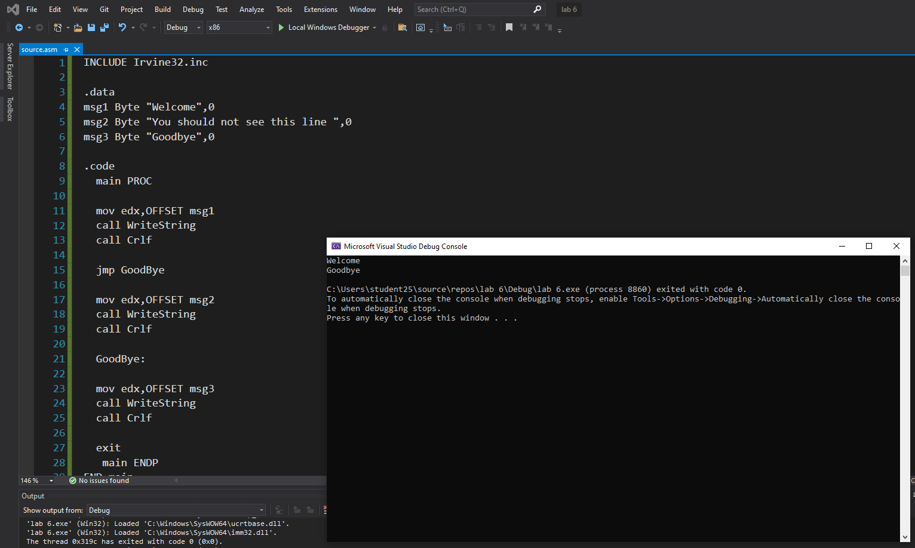

TASK#1 CODE:
INCLUDE Irvine32.inc

.data
msg1 Byte "Welcome",0
msg2 Byte "You should not see this line ",0
msg3 Byte "Goodbye",0

.code
main PROC

mov edx,OFFSET msg1
call WriteString
call Crlf

jmp GoodBye

mov edx,OFFSET msg2
call WriteString
call Crlf

GoodBye:

mov edx,OFFSET msg3
call WriteString
call Crlf

exit
main ENDP
END main

TASK#2:
OUTPUT:
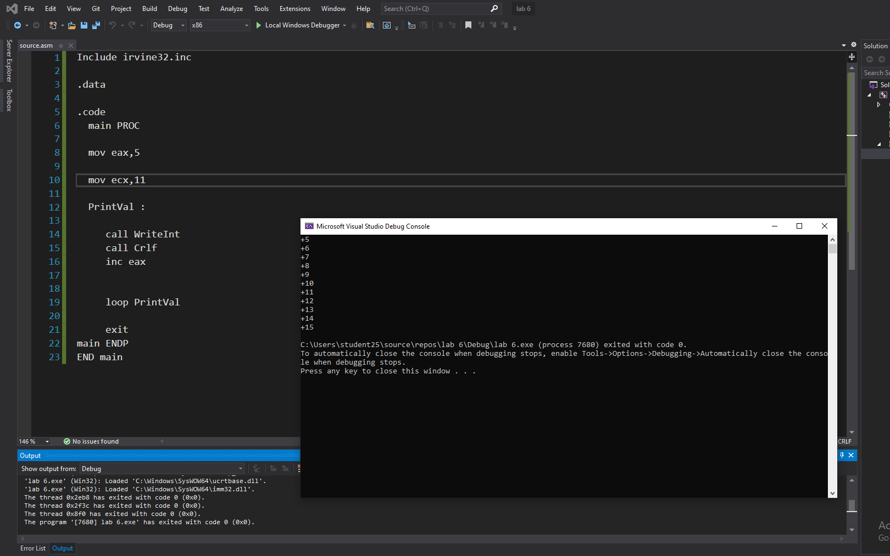

TASK#2 CODE:

Include irvine32.inc

.data

.code
main PROC

mov eax,5

mov ecx,11

PrintVal :

call WriteInt
call Crlf
inc eax

loop PrintVal

exit
main ENDP
END main

TASK#3:
OUTPUT:
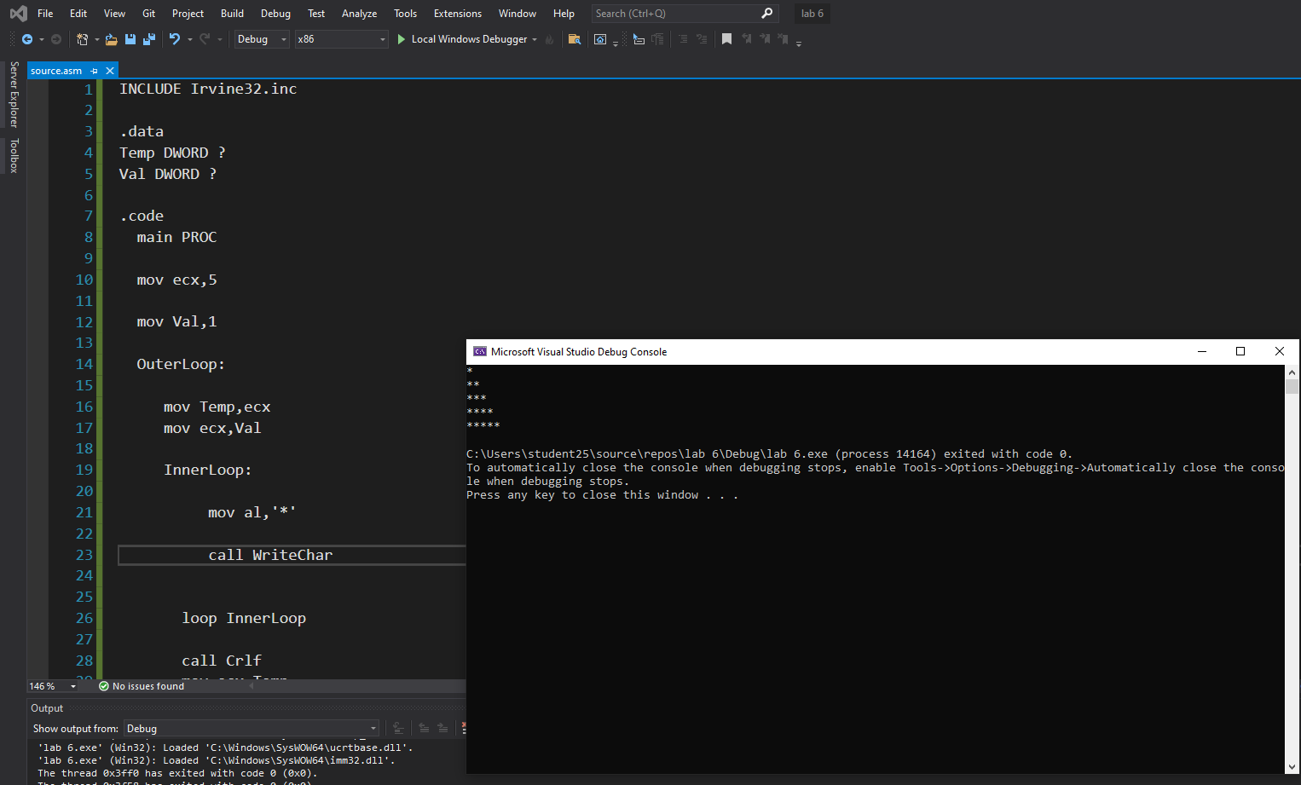

TASK #3 CODE:
INCLUDE Irvine32.inc

.data
Temp DWORD ?
Val DWORD ?

.code
main PROC

mov ecx,5

mov Val,1

OuterLoop:

mov Temp,ecx
mov ecx,Val

InnerLoop:

mov al,'*'

call WriteChar

loop InnerLoop

call Crlf
mov ecx,Temp
inc val

loop OuterLoop

exit
main ENDP
END main

